**DAILY ONLINE ACTIVITIES SUMMARY**

|  |  |  |  |  |  |  |  |  |
| --- | --- | --- | --- | --- | --- | --- | --- | --- |
| **Date:** | **05-06-2020** | | | | | **Name:** | **Ashwini S Jadamali** | |
| **Sem & Sec** | **6th&A** | | | | | **USN:** | **4AL17CS018** | |
| **Online Test Summary** | | | | | | | | |
| **Subject** | | **Operating Research.**  **Python Application Programming. Assignment2** | | | | | | |
| **Max. Marks** | | **OR=30**  **PAP=20** | | **Score** | | | **OR=30**  **PAP=16** | |
| **Certification Course Summary** | | | | | | | | |
| **Course** | **INTRODUCTION TO FULL STACK DEVELOPMENT.** | | | | | | | |
| **Certificate Provider** | | | Greatlearning  Academy | | **Duration** | | | 6hours |
| **Coding Challenges** | | | | | | | | |
| **Problem Statement:** 1. Write a Java program to implement Circular Linked List Using Array And Class.  2. Python program to square each odd number in the list. | | | | | | | | |
| **Status: Done** | | | | | | | | |
| **Uploaded the report in Github** | | | | | **YES** | | | |
| **If yes Repository name** | | | | | **https://github.com/ashwinijadamali/online-coding-activites** | | | |
| **Uploaded the report in slack** | | | | | **YES** | | | |

Online Test Details:

Subject:-Operating Research.

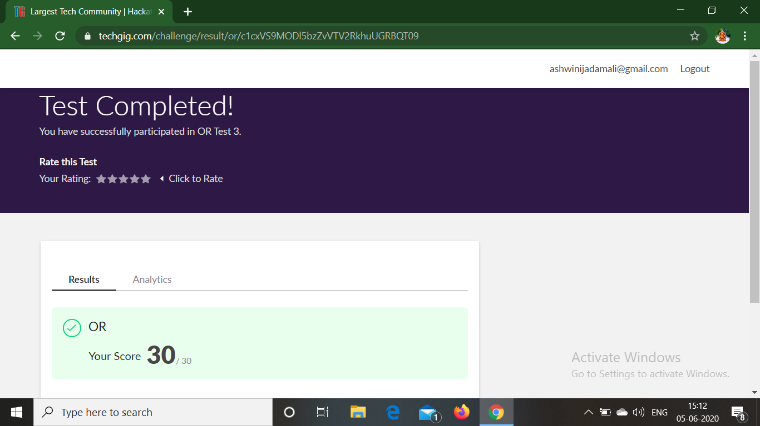

**Python Application Programming**

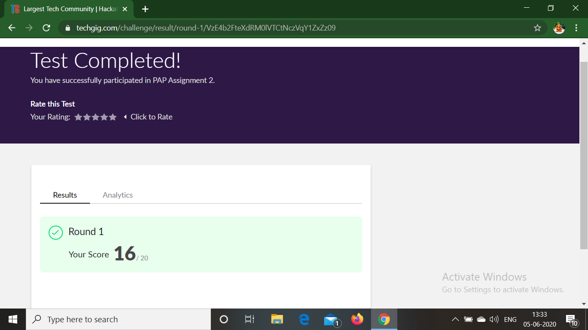

Certification Course Details:

**INTRODUCTION TO FULL STACK DEVELOPMENT.**

Today I have studied :

* Paragraph Tags.
* Paragraph Tags assignment.
* More on head tags.
* More on head tags quiz.
* Heading tag.
* Heading Tag assignment.
* Hr and Br Tags.
* Hr and br tags quiz.
* Anchor Tag.
* Anchor Tag assignment.
* Absolute and Relative path.
* Absolute and Relative path quiz.
* Link it Online.
* Link it Online quiz.

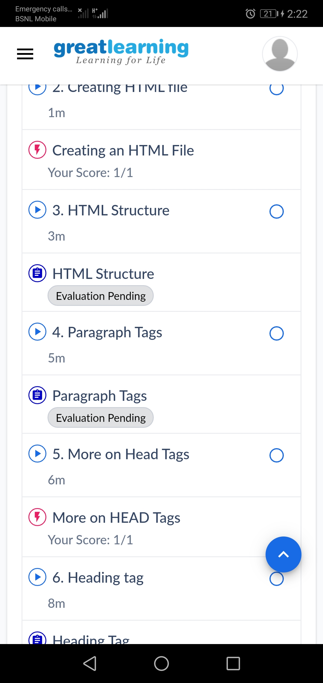

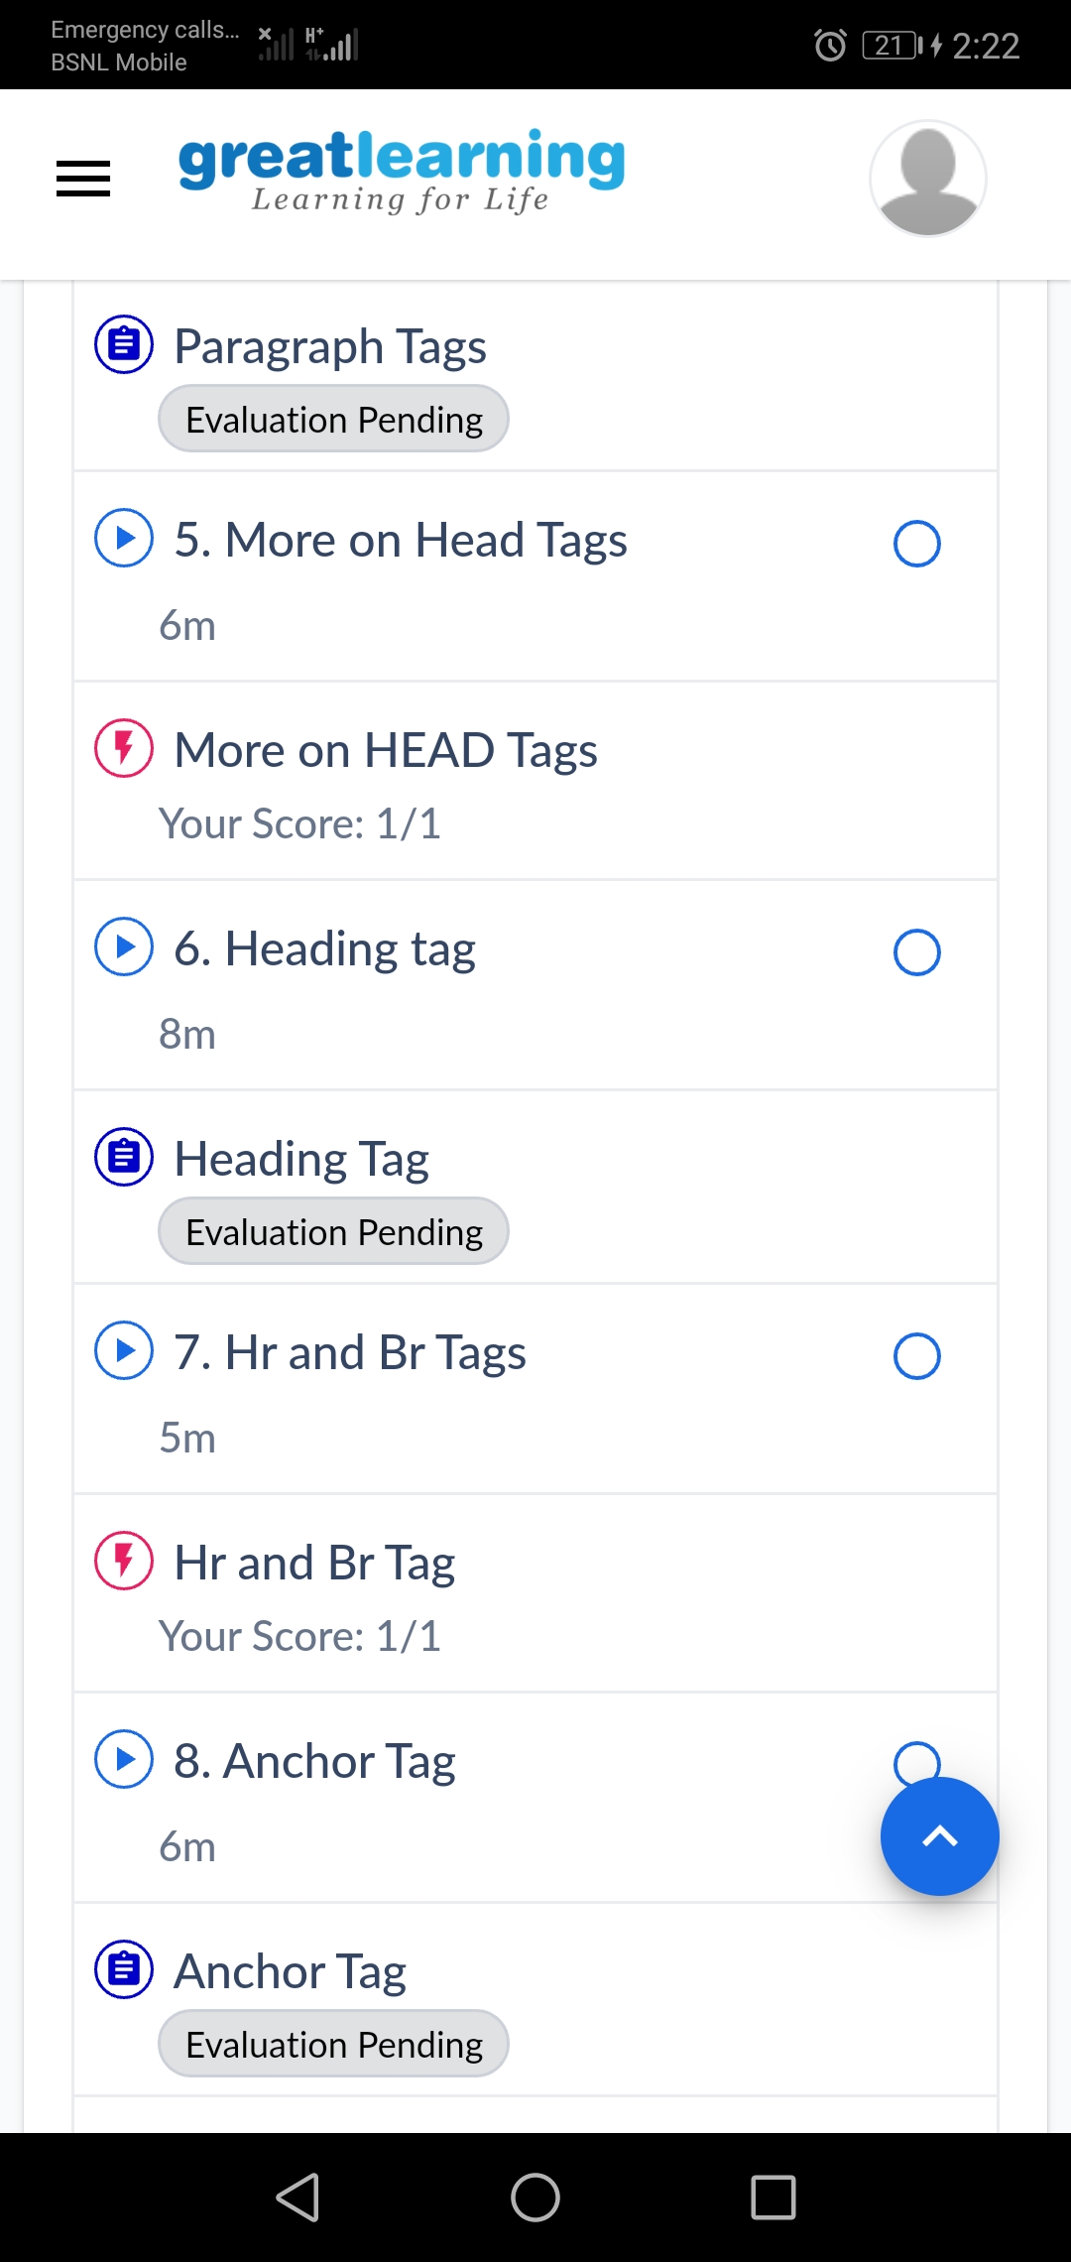

Coding Challenges Details:

1. Write a Java program to implement Circular Linked List Using Array And Class

public class CreateList {

public class Node{

int data;

Node next;

public Node(int data) {

this.data = data;

}

}

public Node head = null;

public Node tail = null;

public void add(int data){

Node newNode = new Node(data);

if(head == null) {

head = newNode;

tail = newNode;

newNode.next = head;

}

else {

tail.next = newNode;

tail = newNode;

tail.next = head;

}

}

public void display() {

Node current = head;

if(head == null) {

System.out.println("List is empty");

}

else {

System.out.println("Nodes of the circular linked list: ");

do{

System.out.print(" "+ current.data);

current = current.next;

}while(current != head);

System.out.println();

}

}

public static void main(String[] args) {

CreateList cl = new CreateList();

cl.add(1);

cl.add(2);

cl.add(3);

cl.add(4);

cl.display();

}

}

**Output:**

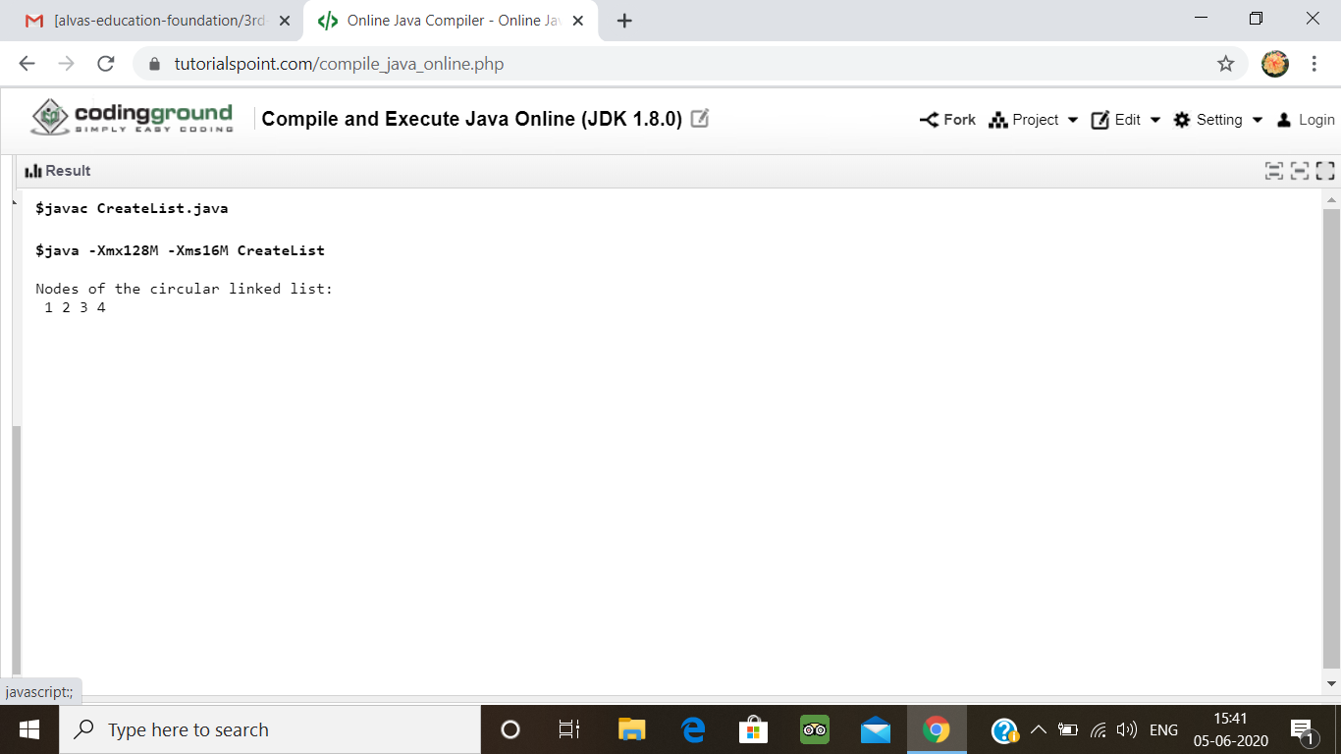

2. Python program to square each odd number in the list

Description:  
Take a list of numbers and square each odd number in the list. Print output as comma separated sequence.  
eg:  
input list: [2,4,5,6,7,8,9]  
output: 25,49,81

L1=[2,4,5,6,7,8,9]

even_sq,odd_sq = [],[]

for i in L1:

(even_sq if i%2==0 else odd_sq).append(i*i)

print(odd_sq)

**output:**

